BN, Feb 28, 2021

Project 6248: Lean Manufacturing Dashboard

Project owner: Mark Young

**Quick screenshot:**

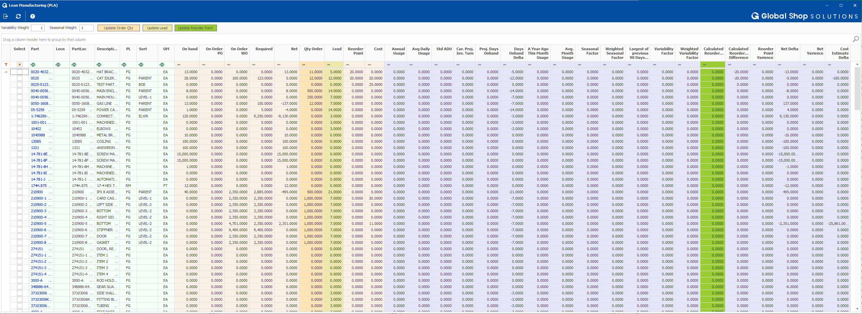

**Left click:**

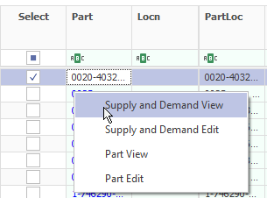

**Right click:**

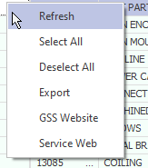

Test Inventory_hist with 270,000 records for a year, time refresh is about 1 minutes and 30 seconds.

**Please read the documentation below and functions of the 3 button:**



**Scope:**

The Lean Inventory Dashboard is an inventory dashboard that uses inventory history and standard industry formulas to calculate what the reorder point should be set to. After evaluating the output, the user can selectively update the inventory master to the calculated value. There are many standard inventory columns and many custom calculated columns that are outlined below.

**Column Sections:**

**White: Inventory Master Static Columns**

* Part/Location
* Description
* Product Line
* Sort Code
* Unit of Measure
* Part Creation Date

**Beige: Inventory Status**

* On Hand: On Hand
* On Order PO: Outstanding on Purchase Order
* On Order WO: Outstanding on Work Order
* Required: Total requirements for the part
* Net On-Hand Less Requirements and Allocations
* Order Quantity (Editable) Batch size (Purchase or MFG’d)
* Lead Time (Editable) Time it takes to procure from trigger (Purchased or MFG’d)
* Current Reorder Point. Current (not calculated) amount to keep on shelf at all times.

**Blue: Calculated Columns**

****In this section the readable formula for explanation will be in black font. Under that the technical formula will be in blue text. ***

**Annual Usage**

$$Annual Usage=Sum of all inventory tranactions with below given transaction types$$

Use for only the following transactions type that affect Usage:

A50:  Stand Alone Issue affects usage (unless option on screen is checked “Do Not Update Part Usage”)

C52: COGS invoices.  Does affect Usage.

J55 (Issue Material to Work Order):  Issue Material to W/O will affect usage. Reverse Issue Material as well.

O35:  Invoicing from inventory, affects usage.

R10\R11:  PO receipt to a WO does affect usage (shows in inventory history as increase/decrease as an R10, but is purchased to Job so it is issued straight to the WO).

T40 Created from Order Entry > Transfer Orders, will affect usage when shipped.

$$Annual Usage=\sum{Inventory_Hist.Quantity}$$

$$Filter on V_Inventory_Hist.Code_Transaction=\text{A50, C52, J55, O35, R10, T4}\text{0}$$

$$Filter on V_Inventory_Hist.Date_Transaction=Today^{'}s Date-365$$

**Average Daily Usage (ADU)**

Description: Summation of the quantity used throughout the past year divided by the standard number of working days in a year (262).

$$Average Daily Usage(ADU)=\frac{Annual Usage}{Working Days}$$

$$Average Daily Usage=\frac{\sum{(V_Inventory_Hist.Quantity}) }{262}$$

**Current Projected Inventory Turns per Part**

Description: The inventory turnover is a measure of the number of times inventory is sold or used in a time period such as a year. A higher number here is desirable. Most industries want a value between 5-10.

$$Inventory Turn Ratio=\frac{Annual Usage}{Current On Hand }$$

$$Inventory Turn Ratio=\frac{\sum{Inventory_History.Quantity}}{Current On Hand }$$

**Projected Days on Hand**

Description: Given current on hand, and average daily usage this is calculated number of days until inventory is exhausted.

$Projected Days on Hand=\frac{Current On Hand }{Average daily usage }$

$$Projected Days on Hand=\frac{Inventory_Mstr.Qty_OnHand }{Average daily usage }$$

**Lead Time & Days On Hand Delta**

Description: A positive value indicates an overstocked amount relatively to the lead time of the part. A negative value indicates that replenishment orders are more likely to need to be expedited.

$$Delta of Days on Hand= Projected Days on Hand-Lead Time$$

$$Delta of Days on Hand= Projected Days on Hand-Inventory_Mstr. Lead Time$$

**Last Year Cur. Month Usage**

Description: total usage for the current month last year.

$$Last Year Cur Month Usage=Sum of all inventory tranactions with below given transaction types$$

$$Last Year Cur Month Usage=\sum{Inventory_Hist.Quantity}$$

$$Filter on V_Inventory_Hist.Code_Transaction=\text{A50, C52, J55, O35, R10, T4}\text{0}$$

$$Filter on Inventory_Hist.Date_Transaction(Month) =CurrentDate.Month and$$

$$Filter on Inventory_Hist.Date_Transaction(Year) =CurrentDate.Year-1$$

**Average Monthly Usage**

Description: Annual Usage divided by 12.

$$Last Year Cur Month Usage=\frac{Sum of all inventory tranactions }{12}$$

$$Last Year Cur Month Usage=\frac{\sum{Inventory_Hist.Quantity}}{12}$$

**Seasonal Factor**

Description A relative value that compares usage for current month and the current month of a year ago. This value can be above or below 1 to account for seasonal demand.

$$Seasonal Factor(SF)=\frac{Last Year Cur. Month Usage }{Average Month useage}$$

$$Seasonal Factor(SF)=\frac{Last Year Cur. Month Usage }{Average Month useage}$$

**Weighted Seasonal Factor**

Description: This is the Seasonal Factor with a user defined weight. The weight is a value between 0 and 1, and defined by the user in the “Seasonal” field (Default is 1). If the user does not want to take the seasonal factor into consideration with the reorder point calculation, they can set the value to 0. This will set the weighted seasonal multiplying factor to 1. Any value greater than 0 but less than 1 will limit the power of the Seasonal Factor. Setting the value to 1 will give the seasonal factor full its full power.

$$Weighted Seasonal Factor=1-(\left(1-Seasonal Factor\right)Seasonal Weight)$$

$$Seasonal Weight\left(SW\right)=User defined value between 0 and 1$$

**Count of Transactions**

Description: Count of the total number of transactions that affect Usage.

$$Count of Transactions= Total transaction count for qualifying trasaction code types$$

$$Count of Transactions=Count:Inventory_Hist.Quantity$$

$$Filter on V_Inventory_Hist.Code_Transaction=\text{A50, C52, J55, O35, R10, T4}\text{0}$$

$$Filter on V_Inventory_Hist.Date_Transaction=Today^{'}s Date-365$$

**Mean Transactional Amount**

Description: Average transactional amount for transactions affecting usage. (Not average daily usage)

$$Mean transactional Amount= \frac{Total Transactional Amount}{Number of transactions }$$

$$Mean Transactional Amount=\frac{\sum_{1}^{n}{Inventory_Hist.Quantity}}{n}$$

$$Filter on V_Inventory_Hist.Code_Transaction=\text{A50, C52, J55, O35, R10, T4}\text{0}$$

$$Filter on V_Inventory_Hist.Date_Transaction=Today^{'}s Date-365$$

**Standard Deviation of Usage**

Description: A statistic that measures the dispersion of a dataset relative to its mean.

$${STD}_{ADU}=\sqrt{\frac{\sum{{\left(Transactional Amount-Mean Transactional Amount\right)}^{2}}}{Total Transactions }}$$

$${STD}_{ADU}=\sqrt{\frac{\sum{{\left(Inventory_Hist.Quantity-Average Daily Usage\right)}^{2}}}{\sum{(V_Inventory_Hist.Quantity }) }}$$

Filter on "V_Inventory_Hist.Code_Transaction"="A50, C52, J55, O35, R10, T40"

Filter on V_Inventory_Hist.Date_Trasaction = Today’s Date -365

**Coefficient of Variance (CoV)**

Description: This takes the standard deviation and normalizes it by dividing it by the mean value making this a unitless number. This normalization of the values makes comparing different parts variances even when there are vastly different quantities between parts.

$$Coefficient of Variance=\frac{Standard Deviation }{Mean Transaction Amount}$$

**Weighted Variance Factor**

Description: This value takes the CoV and weights it by the user defined variance value converts it to a multiplier by adding 1 to it.

$$Weighted Coefficient of Variance=1+\left(CoV*VW\right)$$

Where

$$Variability Weight\left(VW\right)=User defined value between 0 and 1$$

Logic:

As the CoV approaches 0 the multiplying factor goes to 1. As the CoV increases it will cause the multiplying factor to raise above 1 linearly.

**Reorder Point Calculation**

Description: Calculated reorder point factoring in the Seasonal & Variance multipliers

$$Calculated Reorder Point=Lead Time*Average Daily Usage*Weighted Seasonal Factor*Weighted Variability Factor$$

**Calculated Reorder Point Difference**

Description: A positive Value here means reorder point would go up by the difference. A negative means the reorder point should go down by the difference amount.

$$Reorder Point Difference=Calcualted Reorder Point-Reorder Point$$

**Variance of Calculated Reorder point to current Reorder Point**

This will be a percentage to show relative reorder point to the to calculated reorder point levels, a negative percentage indicates that the current reorder point is set too high. Conversely a positive value indicated the reorder point needs to increased.

$$Reorder Point Varience=\left(\left(\frac{Calculated Reorder Point}{Inventory Reorder Point}\right)-1\right)*100\%$$

**Delta of Current net amount to calculated reorder point.**

This value can be positive or negative. the goal of this value is to be as close to 0 as possible. Positive means more parts would need to be ordered to supply the calculated reorder point. A negative value means too many parts are in stock and parts would need to be removed from inventory to match the calculated reorder point

$$Delta of Net =Calculated Reorder Point -Net Amount$$

**Variance of Net and CRoP**

This will be a percentage Positive or Negative to show relative amount of current inventory relative to calculated stock levels.

$$Varience of Stock Level =\left(\left(\frac{Calculated Reorder Point}{Inventory Net}\right)-1\right)*100\%$$

**Delta of Cost Estimate**

This value is the over under value multiplied with the cost of the part pulled from the inventory master cost table. It will give the user an idea of dollar amount difference. if the calculated reorder point is more than the current stock levels the value will be a positive showing roughly how much it would cost to get to the calculated reorder point. If the calculated reorder point is less than current stock levels the value will be negative showing how much extra has been spent.

$$Over/Under Cost Estimate =\left(Calculated Reorder Point -Net\right)*Current Cost$$

**Scope of Dashboard.**

**If the user types in a value in row: Automatically select row**

*Select All:*

If possible there should be a button to select all lines that when check select all lines that have not been filtered using the standard filtering options of the dashboard.

*Refresh:*

The when the user clicks the refresh button the program should first calculate new values for all the formulas above. These values will need to be saved to a custom table. After these values are calculated the grid can be populated.

*Update Lead Time to Inventory Master:*

The Lead time field should originally be populated from the inventory master table but be editable. If the user overwrites the lead time and selects the check box (first column) then presses the Update Lead Time button, the program should update the inventory master lead time field for all lines that have been checked with the user defined lead time.

*Update Order Quantity to Inventory Master:*

The Order field should originally be populated from the inventory master table but be editable. If the user overwrites the Order Quantity and selects the check box (first column) then presses the Update Order Quantity button, the program should update the inventory master lead time field for all lines that have been checked with the user defined lead time.

*Update Calculated Reorder Point to inventory Master:*

This Calculated Reorder Point should originally be populated from the custom calculations table. If the user overwrites the lead time and selects the checkbox (first column) then presses the Update Reorder Point button, the program should overwrite the inventory master Reorder Point field for all lines that have been checked with the user defined Order Quantity.

The Calculated Reorder Point field should be editable if the user wants to override the calculated amount.

Each row should have a normally unchecked box that the user can check if they to want to update the reorder point to the calculated value. Once the user has selected all lines they desire to update they can select an button in the header titled “Update to Inventory Master” where these changes will write to the reorder point field of the inventory master.